THE HUB: A Collaborative Learning Space
The Hub is a central, flexible and welcoming space designed for students in Preschool through 5th grade. It serves as an extension of the classroom for fostering literacy, curiosity, enrichment learning and digital citizenship.

Students will:
- Develop a love of reading by exploring stories, ideas and knowledge in print and digital formats
- Strengthen digital citizenship and responsible technology use
- Engage in enrichment activities and classes that extend classroom learning
- Cultivate curiosity, inquiry and critical thinking by analyzing and synthesizing information
- Grow academically, socially and spiritually in partnership with teachers who guide, support, and reflect alongside students

Key Features of The Hub
- Flexible seating and learning areas for group instruction and individual exploration
- Resources curated to support enrichment learning, literacy and digital exploration
- Teacher-led experiences that promote guided inquiry, discussion and critical thinking
- Opportunities for students to connect stories and information across subjects while nurturing curiosity and a lifelong love of learning

The H.U.B. Pathway: Harnessing, Understanding, Becoming
H – Harnessing
To actively gather, focus, and direct curiosity, ideas, and information toward meaningful learning. Students harness information by selecting, exploring, and using it to answer questions, solve problems, and discover new ideas.

How students will harness Information:
- Notice: Identify interesting stories, facts, or ideas in books, articles, or digital media.
- Collect: Gather information that relates to your questions or learning goal.
- Focus: Decide what is most important or relevant to explore further.
- Apply: Use the information to create, share, or reflect on your understanding.

Analogy:
Harnessing information is like gathering water from a river to fill a garden.
- You notice where the water flows → find sources of information
- You collect the water carefully → choose reliable, relevant information
- You direct it where it’s needed → focus on key ideas
- You use it to help your garden grow → apply knowledge to learning
Teacher-Student Partnership:
Teachers guide students to identify trustworthy sources, ask guiding questions, and reflect on how to focus and use information. Students practice active thinking and curiosity while teachers model strategies for selecting, organizing, and applying information.

U – Understanding
To make sense of ideas, see relationships between information, and form meaningful connections. Students understand by analyzing, synthesizing, and reflecting on information to create new ideas and solve problems.
How You Understand Information:
- Compare: Look for similarities and differences between ideas, texts, or sources.
- Analyze: Break information into parts to see how it works.
- Synthesize: Combine ideas from multiple sources to form new understanding.
- Reflect: Think about how the information connects to what you already know or believe.
Analogy:
Understanding information is like sorting puzzle pieces to see the whole picture.
- You compare shapes and colors → notice patterns and connections
- You analyze how pieces fit → examine details and relationships
- You combine pieces → synthesize ideas into new understanding
- You step back and see the picture → reflect on the meaning
Teacher-Student Partnership:
Teachers ask open-ended questions, model thinking aloud, and guide students in connecting information across texts and experiences. Students collaborate with teachers to deepen comprehension and explore multiple perspectives.

B – Becoming
The ongoing process of growth—intellectually, socially, and spiritually. Students become confident, thoughtful, and Christ-centered learners who apply knowledge, make decisions, and contribute positively to their world.
How You Become a Learner:
- Practice: Use new knowledge and skills in real situations.
- Collaborate: Work with others to solve problems and share ideas.
- Reflect: Consider what you’ve learned and how you’ve grown.
- Apply: Use learning to help, serve, or create in meaningful ways.
Analogy:
Becoming is like planting a seed and helping it grow into a strong tree.
- Practice → water and sunlight for growth
- Collaborate → supportive soil and environment
- Reflect → notice how the tree grows and changes
- Apply → bear fruit that benefits others
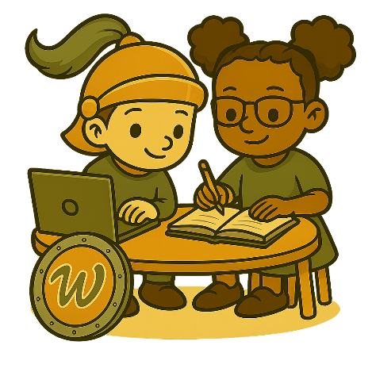
Teacher-Student Partnership:
Teachers mentor and encourage students, providing feedback, guidance, and reflection opportunities. Students actively participate in their growth, applying learning in enrichment classes, digital exploration, and reading experiences.

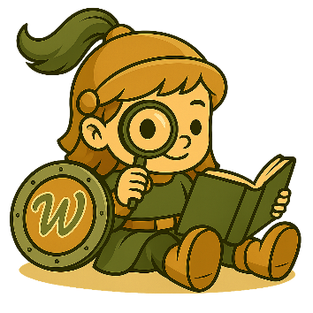
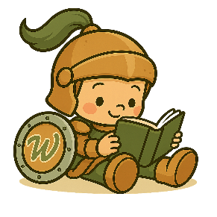
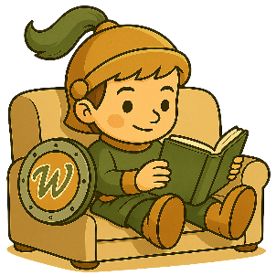
Title / Role | Purpose / Responsibilities | Reports To
Head of School | Provides overall vision; ensures alignment of The Hub with school mission and Christ-centered learning; approves budget, staffing, and strategic initiatives. | School Board / Governance
Principal | Oversees PreK–5 campus operations, including The Hub; coordinates with AP, counselors, media specialists, and teachers to integrate Hub programs. | Head of School
Assistant Principal | Supports daily operations, scheduling, and enrichment program coordination; facilitates communication between teachers, specialists, and families. | Principal
School Counselor | Provides social-emotional guidance; supports literacy and enrichment goals; assists with student leadership and volunteer programs. | Principal
Media Specialist – Literacy & Enrichment Focus | Curates print collections, reading programs, and coordinates enrichment signature programming; designs and leads literacy enrichment experiences; partners with classroom teachers. | Principal
Media Specialist – Technology | Curates digital resources, teaches digital citizenship; supports technology integration in enrichment classes; collaborates with teachers. | Principal
Classroom Teachers | Deliver curriculum; coordinate with media specialists to extend learning in The Hub; support student engagement. | Principal / AP
Teacher Assistants | Support student engagement, small-group work, and guided enrichment activities in The Hub. | Classroom Teachers
Parent Partner Volunteers | Assist with reading programs, events, and special projects; support student engagement under supervision. | Media Specialists
Student Leadership | Support younger students; model library behavior; assist classroom activities. Help peers with technology use and digital citizenship activities under guidance.  Promote reading programs; curate book displays; assist with enrichment events. | Media Specialists

Nonfiction Genres in the Hub
  - ☐Animals: Wildlife, habitats, classifications, endangered animals.

  - ☐ Pets & Veterinary Care
- Domestic animals, pet guides, caring for creatures.
  - ☐ Space & Astronomy
- Planets, stars, astronauts, space exploration.
  - ☐ Earth Science
- Weather, natural disasters, rocks/minerals, ecosystems.
- ☐ Human Body & Health
Body systems, wellness, nutrition.
- ☐ Science & STEM
General science concepts, experiments, inventions.
- ☐ Technology & Coding
Computers, robotics, digital tools, coding basics.
- ☐ Transportation & Engineering
- Planes, trains,
- Automobiles
- Boats and submarines
- construction, machines.
- ☐ History & Civilizations
  - Ancient cultures, historical eras, timelines.
- ☐ Geography & Cultures
  - Countries, maps, traditions, world cultures.
- ☐ Sports

- Biography
  - Famous people, leaders, athletes, artists, inventors.
13. Arts & Music
Artists, musicians, crafts, drawing, theater.
14. Nature & Environment
Plants, biomes, conservation, outdoor exploration.
15. ☐ Government & Citizenship
Community helpers, civics, laws, leadership.
16. ☐ Social-Emotional Learning
Feelings, friendship, growth mindset, character development.
17. Faith & Values
Bible stories, Christian living, character traits (aligned to your mission).
18. ☐ How-To & DIY
Crafts, cooking, building, life skills.
19. ☐ Math in Real Life
Math concepts, problem solving, patterns, puzzles.
20. ☐ Weird, Wacky & Wonder
Ripley’s style facts, curiosities, mysteries, “fun fact” nonfiction.
Elementary Reading Program (DRAFT)
PK–5 | Aligned to Florida Department of Education B.E.S.T. Standards

LIBRARY MISSION
To cultivate lifelong readers who read widely, think deeply, and choose books that spark curiosity, character, and joy.
We believe:
- Reading is both a skill and a gift.
- Students grow through wide reading across genres, formats, and topics.
- Reading for pleasure builds stamina, vocabulary, empathy, and academic strength.
- Choice motivates readers more effectively than restriction.
- Sustained independent reading builds stronger readers than constant level-monitoring.

LIBRARY PURPOSE
The Elementary Library Program exists to:
- Support literacy growth aligned to Florida’s B.E.S.T. ELA Standards.
- Foster a culture of reading for enjoyment and exploration.
- Encourage reading across genres, cultures, formats, and complexities.
- Build independent readers who develop stamina and ownership.
- Utilize Accelerated Reader (AR) as a motivational tool — not a limitation.
- Teach responsible book selection and reflection.
- Promote sustained reading habits over strict ZPD confinement.

📖 PROGRAM PHILOSOPHY
Wide Reading > Narrow Leveling
Students are encouraged to:
- Read within, above, and below their ZPD.
- Explore fiction, nonfiction, poetry, biography, graphic novels, and informational text.
- Revisit comfort books.
- Try challenging texts with support.
Sustained Reading > Constant Testing
We prioritize:
- Independent reading stamina.
- Daily/weekly sustained silent reading.
- Book talks and peer recommendations.
- Reflection conversations over excessive quizzes.
AR as Motivation
AR is used to:
- Encourage goal setting.
- Celebrate reading milestones.
- Track volume of reading.
- Build accountability.
AR is not used to:
- Restrict book choice.
- Define identity as a reader.
- Replace reading conferences or comprehension conversations.

Reading Expectations by Grade Level
(Aligned progressively to B.E.S.T. ELA standards for comprehension, vocabulary, and text complexity.)

Grade | Focus | Expectations
PK3 & PK4 | - Listening comprehension  - Print awareness  - Book handling skills  - Love of stories | - Participate in daily read-alouds.  - Retell stories orally with support.  - Explore picture books independently.  - Demonstrate beginning book care skills.  - Engage in “wide listening” — fiction, nonfiction, Bible stories, poetry.  - No AR participation.
Kindergarten | - Concepts of print  - Story structure  - Beginning decoding  - Oral retell | - Choose books weekly.  - Participate in sustained picture-book browsing.  - Retell beginning/middle/end.  - Recognize author and illustrator roles.  - Develop reading stamina (5–10 minutes sustained attention).  - Optional introduction to AR late spring (teacher discretion).
First | - Foundational decoding  - Fluency development  - Comprehension monitoring | - Weekly book checkout.  - 10–15 minutes sustained reading.  - Retell with key details.  - Begin identifying genre.  - Participate in AR (developmentally appropriate goals).  - Encourage wide reading: easy readers, nonfiction, early chapter books, graphic formats.  Students may read outside ZPD for enjoyment.
Second | - Independent reading growth  - Vocabulary development  - Story elements and informational text features | - 15–20 minutes sustained reading.  - AR participation with individualized goals.  - Explore multiple genres each quarter.  - Read both fiction and nonfiction regularly.  - Reflect briefly on reading (oral or written).  - Practice book selection strategies (Five-Finger Rule as guide, not rule).  Choice remains primary driver.
Third | - Reading stamina  - Text evidence  - Genre comparison  - Informational text analysis | - 20–25 minutes sustained reading.  - AR goal-setting per quarter.  - Read across at least 5 genres annually.  - Participate in book talks.  - Read at least one “stretch” book per quarter.  - Engage in light reading reflection or discussion.  Students may exceed ZPD with teacher guidance.
Fourth | - Deeper comprehension  - Theme and main idea  - Cross-text connections  - Research integration | - 25–30 minutes sustained reading.  - Quarterly AR point goals.  - Wide reading including:  - Historical fiction  - Biography  - Informational science/social studies  - Fantasy  - Poetry  - At least one sustained novel per quarter.  - Participation in reading celebrations or challenges.  Encourage complex text exploration while maintaining joy.
Fifth | - Analytical thinking  - Argument and perspective  - Text complexity readiness  - Reading independence | - 30+ minutes sustained reading.  - Independent AR goal management.  - Wide reading across:  - Multiple cultures  - Multiple time periods  - Varied author voices  - Multiple text complexities  - Engage in peer book recommendations.  - Complete at least one long-form novel per quarter.  - Practice reflective reading (journal, discussion, or presentation).  Students prepare for middle school reading independence.

AR Framework
- Goals individualized by grade and reading development.
- Points celebrate volume, not speed.
- Reading comprehension average target: 80%+.
- Incentives tied to milestones, not competition.
- Students encouraged to read:
  - 1 comfort book
  - 1 challenge book
  - 1 interest-based book per cycle

📚 Wide Reading Expectations (PK–5)
By the end of 5th grade, students will have experienced:
- 10+ genres
- Fiction & nonfiction balance
- Poetry
- Biography
- Informational text
- Graphic novels
- Faith-based literature
- Diverse cultural perspectives
- Series reading
- Stand-alone novels
- Read-aloud classics

🏆 Reading Culture Commitments
Our library will:
- Celebrate reading publicly.
- Feature rotating genre displays.
- Highlight student recommendations.
- Host reading challenges focused on variety.
- Emphasize reading identity over reading level.
- Encourage family reading partnerships.
- Protect time for sustained silent reading.

💡 Guiding Principle
We do not raise strong readers by narrowing their choices.
We raise strong readers by widening their world.

